Population Wise Deposite
Project Overview
This project analyzes deposit patterns across different population groups and regions using banking data. The main goal is to understand how deposits vary based on population categories such as rural, semi-urban, urban, and metropolitan areas. By using data visualization and analysis tools, the project helps identify trends, customer behavior, and financial growth opportunities for banks and financial institutions.
The project includes data cleaning, transformation, and visualization techniques to generate meaningful insights from the dataset. Interactive dashboards and charts are used to compare deposit amounts, branch distribution, and regional performance effectively.

Objectives
- To analyze total deposits across different population groups.
- To identify which region or population category contributes the highest deposits.
- To compare banking performance between rural, urban, and metropolitan areas.
- To create interactive dashboards for better decision-making.
- To understand customer deposit trends and financial inclusion levels.
- To support banks in improving branch planning and investment strategies.
Data Sources
- Understanding deposit trends across different population groups
- Comparing banking performance by region
- Identifying high and low deposit areas
- Supporting dashboard visualization and business insights generation

Problem Statement
- Banking deposit distribution varies across different population groups.
- Financial institutions face challenges in identifying high-performing deposit regions.
- Rural and semi-urban areas often show lower banking participation compared to urban regions.
- Lack of proper data analysis makes it difficult to understand customer deposit behavior.
- Banks need better insights to improve branch planning and resource allocation.
- Identifying deposit growth trends across regions is important for strategic decision-making.
- Manual analysis of large banking datasets is time-consuming and less accurate.
- Interactive dashboards are required to monitor deposits and regional banking performance effectively.

Tools & Technologies
- Microsoft Excel – Data cleaning, sorting, filtering, and basic analysis
- Power BI – Interactive dashboard creation and data visualization
- SQL – Data querying, filtering, and analysis
- Power Query – Data transformation and preprocessing
- DAX (Data Analysis Expressions) – Creating calculated measures and KPIs in Power BI
- CSV Dataset – Source file format used for analysis
- Charts & Visualizations – Bar charts, pie charts, maps, KPI cards, and slicers for insights presentation
- Data Modeling – Establishing relationships between data fields for accurate reporting
- Business Intelligence Techniques – Used for trend analysis and decision-making support

Data Pre-Processing (Excel / Power Query)
- Imported the banking deposit dataset from CSV/Excel format into Power Query.
- Removed duplicate and unnecessary records from the dataset.
- Checked and handled missing or null values for better accuracy.
- Renamed column headers for better readability and understanding.
- Changed incorrect data types such as text, whole number, decimal, and date formats.
- Filtered unwanted rows and cleaned inconsistent data entries.
- Standardized population group names such as Rural, Semi-Urban, Urban, and Metropolitan.
- Created calculated columns and measures required for analysis.
- Verified data consistency and accuracy before visualization.
- Loaded the cleaned and transformed data into Power BI for dashboard creation and reporting.

Data Modelling and DAX (Power BI)
- Imported the cleaned dataset into Power BI for analysis and reporting.
- Established relationships between tables using common fields such as State Code, District Code, and Population Group.
- Created a structured data model to improve data connectivity and performance.
- Used star schema concepts for efficient dashboard development.
- Developed calculated measures using DAX (Data Analysis Expressions).
- Created KPIs to measure total deposits, number of accounts, and branch performance.
- Applied aggregation functions such as SUM, COUNT, AVERAGE, and DISTINCTCOUNT.
- Used filters and slicers for dynamic and interactive dashboard analysis.
- Implemented time-based calculations for year-wise deposit comparison.
- Optimized the data model for faster visualization and reporting performance.
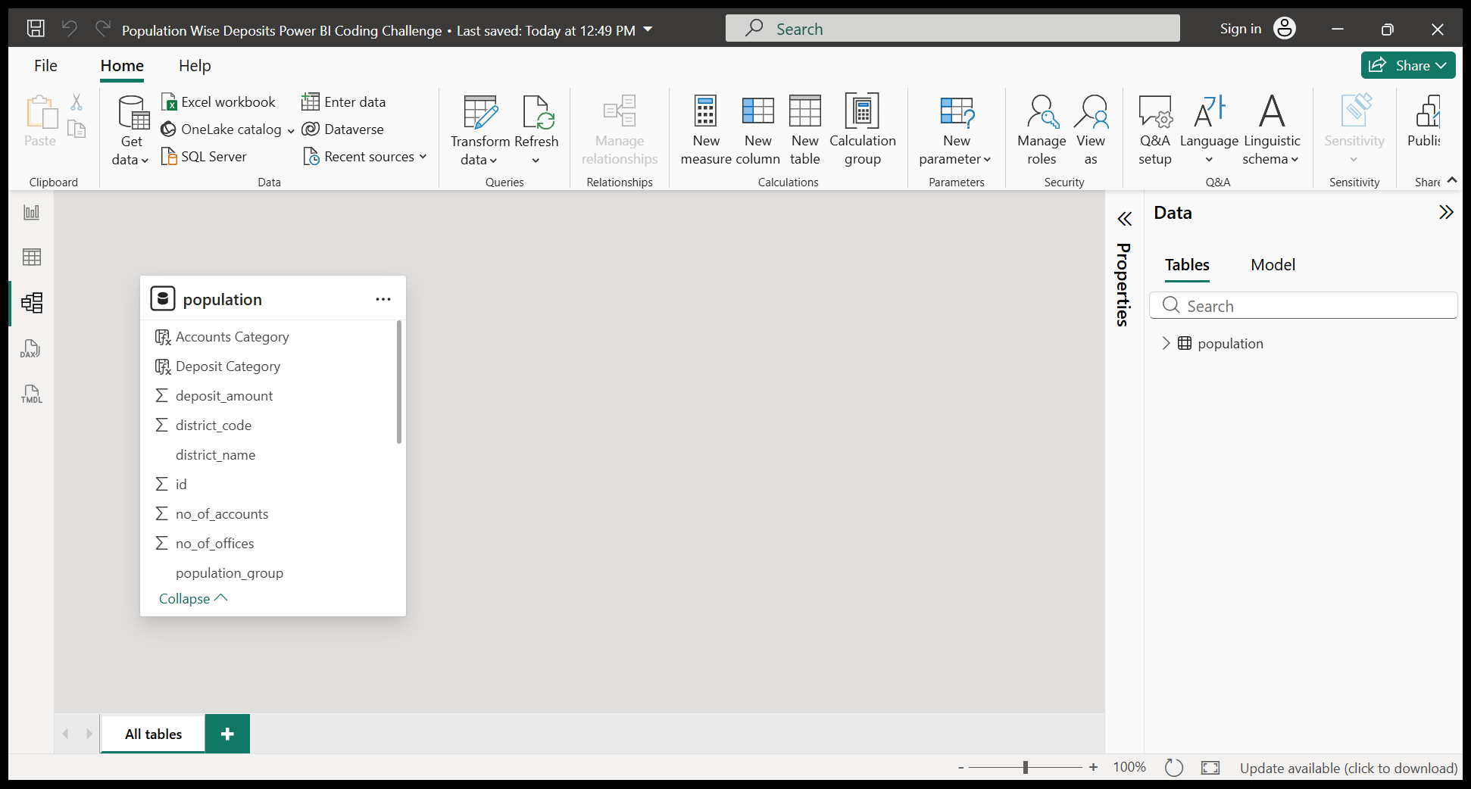

8. Analysis and Visualizations (Power BI)

Dashboard Features
- Interactive dashboard to analyze population-wise banking deposits.
- KPI cards displaying Total Deposits, Total Accounts, and Total Offices.
- Clustered column charts to compare deposits across population groups.
- Pie charts showing percentage contribution of each region.
- Map visualization for state-wise banking deposit analysis.
- Bar charts to compare branch distribution and account counts.
- Slicers for filtering data by State, Region, Year, and Population Group.
- Trend analysis using line charts for year-wise deposit growth.
- Drill-down functionality for detailed regional analysis.
- Dynamic visuals enabling quick comparison between rural, urban, semi-urban, and metropolitan areas.
- Data labels and tooltips added for better user understanding.
- User-friendly layout designed for easy navigation and decision-making support.
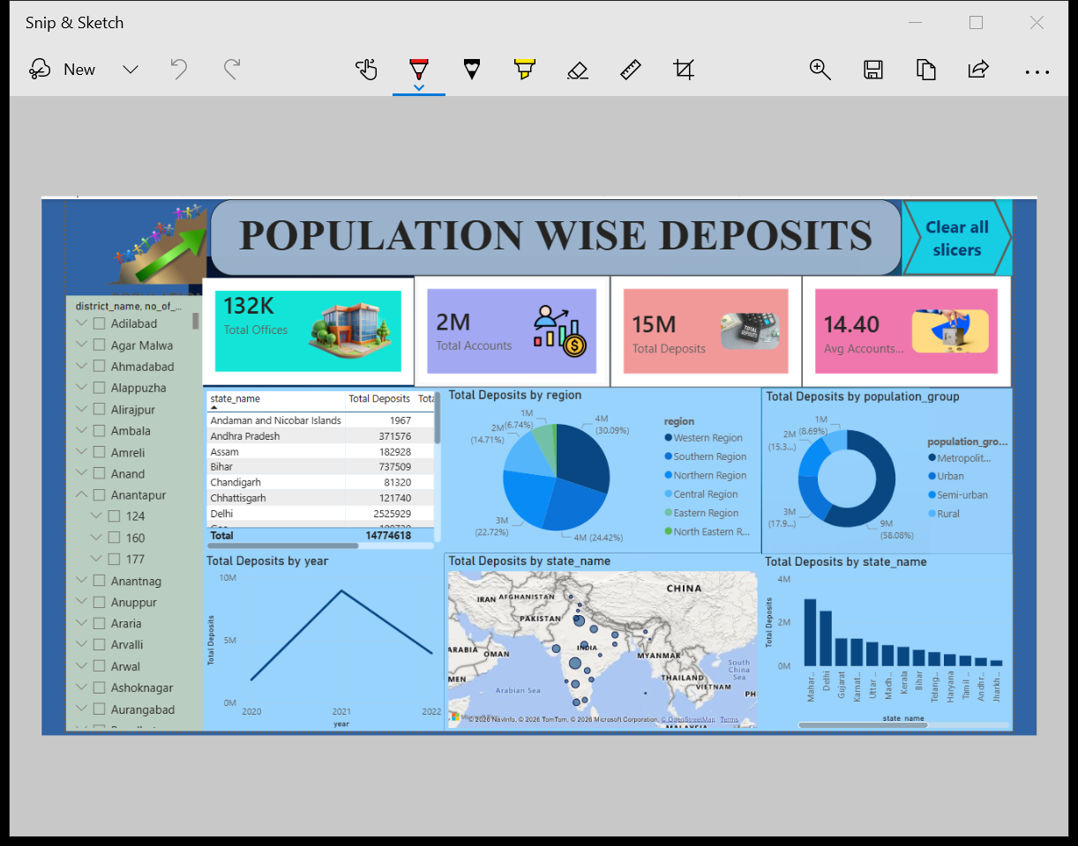

Insights
- Urban and metropolitan regions recorded the highest deposit amounts compared to rural areas.
- Rural regions had fewer banking offices and lower deposit contributions.
- Semi-urban areas showed steady growth in both accounts and deposits.
- States with a higher number of bank branches generally achieved higher deposit values.
- Customer account growth positively influenced overall deposit performance.
- Some districts maintained strong deposits despite having fewer offices, indicating high customer engagement.
- Deposit trends increased consistently over the years in major banking regions.
- Interactive filtering helped identify top-performing and low-performing regions quickly.
- Regional comparison showed differences in banking penetration and financial inclusion.
- Visual analysis improved understanding of deposit distribution across population groups.

Conclusion
- The Population Wise Deposits analysis highlights clear differences in banking deposits across rural, semi-urban, urban, and metropolitan regions. Urban areas dominate in total deposits, while rural regions show growth potential. The dashboard helps banks identify trends, improve financial inclusion, and make data-driven decisions for better branch and resource planning.

